Lockdown

Activity Ideas

See below a list of activities and ideas that may help support boredom during lockdown.

These will help in maintaining participation, motivation and general well-being during these challenging times.

It is also important to remember to establish a new daily routine during this time; structure is still an incredibly important part of autism friendly support and those who will be struggling with the change to their usual routines and the stress of this situation.

Ways to re-establish structure:

* Follow a similar pattern for the day that you used to - get up, go to bed, eat meals and take your daily walk at around the same time each day.
* Keep busy – have a timetable of activities that are balanced between relaxation, skill building and fun.
* Carry on looking after yourself – don’t skip self-care tasks just because you’re not going out
* Get outside every day for fresh air (either going for a walk or into the garden)
* Very importantly – make sure you replace important routines with new ones, for example - Instead of walking to the shop to get a magazine every Monday, make sure it is delivered instead. Instead of going out for a weekly meal, cook something special on that day or get a takeaway. Daily walks aren’t that varied so take a flask of coffee, something nice to eat while you’re out or a camera to take photos. If you normally go to the pub on Fridays, get some beers and peanuts in and watch a film. Schedule times to phone or video call friends and family when you would normally have visited them.

|  |
| --- |
| **Arts and Crafts** |
| * Sewing, crochet or knitting * Make wool Poms Poms * Make tissue paper flowers * Natural art with materials found in the garden; collect fallen leaves, petals and sticks * Tie dye paints for clothing * Painting and colouring books * Making paper aeroplanes and boats (simple origami) then race them or hang them up * Jewellery making with string and beads * Draw chalk pictures in the garden * Sketching and drawing * Making a story book or comic * Dip dying eggshells for Easter |
| Further ideas link: <https://www.happinessishomemade.net/quick-easy-kids-crafts-anyone-can-make/> |

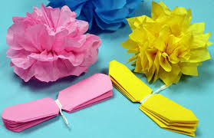

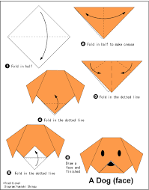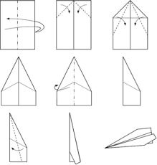

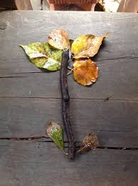

|  |
| --- |
| **Gardening** |
| * Plant herbs to use in cooking * Make your own vegetable plot * Organise and tidy the garden * Insect spotting game * Chalk pictures on the fence panels or patio * Natural art with leaves and stones etc * Outdoor garden games (giant chess/Jenga) * Make a mini garden in a plant pot * Grow some flowers * Make an obstacle course * Organise your own sports day * Make a bird feeder * Go bird watching * Make a hedgehog or bug hotel |
| Further ideas link: <https://wonderadventures.co.uk/fun-and-free-garden-activities-for-kids/> |

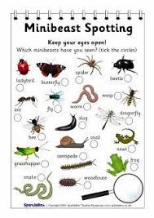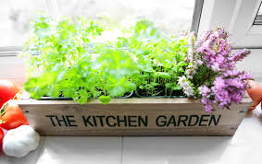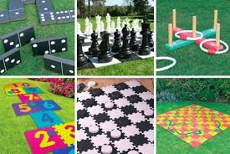

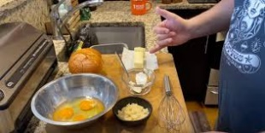

|  |
| --- |
| **Cooking** |
| * Learn to bake and make cakes and biscuits * Hold an afternoon tea or a little garden party * Learn new simple recipes * Get involved with cooking the evening meal * Help put together weekly menus * Reorganise the kitchen * Make your own playdough * Make your own recipe book * Decorate biscuits * Cut your sandwiches into fun shapes * Prepare a picnic to eat in the garden * Or, have an indoor picnic |
| Further ideas link: <https://www.jennyfriedmannutrition.com/blog/cooking-with-an-autistic-child> |

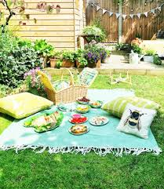

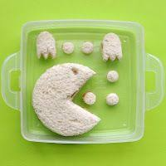



|  |
| --- |
| **Table Top and Indoor Activities** |
| * Board game competitions * Make a Mini Quiz or play Bingo * Chat with staff about your day * Make a matching game using pictures of staff, family or celebrities you like * Plan a wall within your house to decorate with your pictures * Experiment with a new art or science kit * Have a Lego building competition with your staff * Make invites to send your staff and invite them to a mini tea party * Write a funny story with your staff or housemates * Make fun sensory items from household objects * Do an indoor treasure hunt * Read books or magazines * Make a mood board of all the things you like * Blow bubbles |
| Further Sensory ideas link: <https://www.learning4kids.net/list-of-sensory-play-ideas/> |

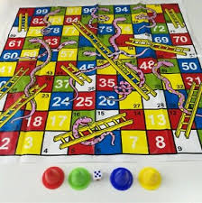

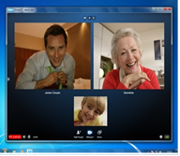

|  |
| --- |
| **Technology** |
| * Download new fun games to play on your iPad, phone or computer. * Draw in Paint on the computer * Watch funny YouTube videos * Watch your favourite show on Netflix or have a movie night with popcorn * Play audio books or happy music * Video call or speak on the phone with your family * Research your favourite characters or a new project * Make a PowerPoint about what you like to do * Look for funny, beautiful or interesting pictures on Google and make a collage * Take funny photos or yourself and staff members (with their permission!) * Do a virtual tour online – you can watch Zoo webcams or visit museums * Stream free theatre performances (google ‘free National Theatre’ or ‘The Shows Must Go on’) * Learn a new language on apps like Duolingo or Youtube videos |
| Apps that support and empower Autistic individuals: <https://mashable.com/2016/04/02/autism-apps/?europe=true> |

[](https://www.google.co.uk/url?sa=i&url=https%3A%2F%2Fwww.techspot.com%2Fnews%2F83851-notepad-paint-wordpad-become-optional-features-windows-10.html&psig=AOvVaw2C-qOfqcG2r7hJTMVzeIA6&ust=1586514547675000&source=images&cd=vfe&ved=0CAIQjRxqFwoTCPj53KqR2-gCFQAAAAAdAAAAABAK)[](https://www.google.co.uk/url?sa=i&url=https%3A%2F%2Ftotallythebomb.com%2Fyou-can-take-virtual-tours-of-museums-for-an-online-field-trip-with-your-kids&psig=AOvVaw3Y3MS3Yn8oREbsXxflBDpc&ust=1586514746557000&source=images&cd=vfe&ved=0CAIQjRxqFwoTCOiTwYmS2-gCFQAAAAAdAAAAABAK)

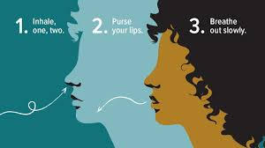

|  |
| --- |
| **Exercise and Relaxing Activities** |
| * Have a nice relaxing bubble bath * Try following a gentle yoga, dance or exercise video on YouTube (e.g. Joe Wicks workout) * Listen to a meditation guide or sleep story on YouTube, Calm or Headspace. * Make your own foot spa with bubbles * Ask staff to do your hair or make up * Try some deep breathing exercises * Tell staff about how you are feeling and write down questions you have * Have some alone time * Go outside for your daily exercise * Throw or kick a ball or balloon around * Throw balls into a basket * Play indoor bowling * Try puzzles, colouring, crosswords or dot to dot * Have a pamper evening – face masks, paint nails, foot spa etc. |
| Simple ways to relax at home: <https://greatist.com/happiness/40-ways-relax-5-minutes-or-less> |

[](https://www.google.co.uk/url?sa=i&url=https%3A%2F%2Fstriki.ng%2Fblogs%2Fnews%2Fthe-10-most-important-yoga-poses-for-beginners&psig=AOvVaw0Q9VYoZ5mOaFsAoPQ7zDcJ&ust=1586515051454000&source=images&cd=vfe&ved=0CAIQjRxqFwoTCPjz_JqT2-gCFQAAAAAdAAAAABAK)

|  |
| --- |
| **Musical Activities** |
| * Have an indoor disco – turn music and lights on and dance * Plan a living room talent competition * Plan a karaoke evening * Watch a Disney sing along or musicals * Skipping games * Clapping games or songs with actions (e.g. head, shoulders, knees, and toes) * Play musical games e.g. musical statues/chairs * If you have an Alexa ask her to play games like Freeze Dancers * Do a music making game online – <http://musiclab.chromeexperiments.com/> * Use household items as musical instruments (e.g. pots and pans, beads or stones in a bottle to make shakers or cover cans to make drums) * Make windchimes for the garden * Do a drum circle |
| Further ideas link: <https://www.musictogether.com/musical-games> |

[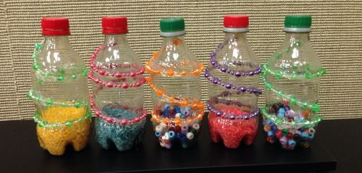](https://www.google.co.uk/url?sa=i&url=https%3A%2F%2Fwww.pinterest.com%2Fpin%2F149533650102888175%2F&psig=AOvVaw2XMgVMR9dmjBr4EfAvAOwN&ust=1586516552141000&source=images&cd=vfe&ved=0CAIQjRxqFwoTCLiSx-aY2-gCFQAAAAAdAAAAABAi)[](https://www.google.co.uk/url?sa=i&url=https%3A%2F%2Ftwitter.com%2Fbrandnewkorea%2Fstatus%2F881132834223554561&psig=AOvVaw03YcdrmVboc-p4DaEHDIbT&ust=1586516218825000&source=images&cd=vfe&ved=0CAIQjRxqFwoTCIi80ceX2-gCFQAAAAAdAAAAABAV)

[](https://www.google.co.uk/url?sa=i&url=https%3A%2F%2Flogos.fandom.com%2Fwiki%2FDisney_Sing_Along_Songs&psig=AOvVaw3fB29RRal8xjXs81uql2Pr&ust=1586516961420000&source=images&cd=vfe&ved=0CAIQjRxqFwoTCJCL2qma2-gCFQAAAAAdAAAAABAE)[](https://www.google.co.uk/url?sa=i&url=https%3A%2F%2Fwww.realplaycoalition.com%2Factivities-for-kids%2Fhead-shoulders-knees-and-toes%2F&psig=AOvVaw325Pfumk3-OCXJ6klg7JAm&ust=1586516304701000&source=images&cd=vfe&ved=0CAIQjRxqFwoTCJi6xPCX2-gCFQAAAAAdAAAAABAE)[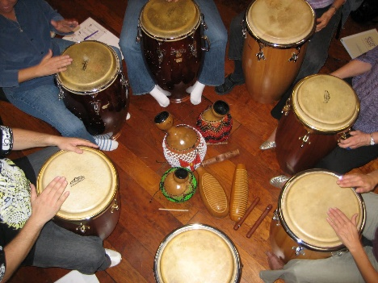](https://www.google.co.uk/url?sa=i&url=https%3A%2F%2Fbasicdrummer.com%2Fmusicians-expect-drum-circle-djembes-congas-hand-drums-get-together-rumble%2F&psig=AOvVaw158fyzFtLkdCK2zu0UK6Mm&ust=1586516886146000&source=images&cd=vfe&ved=0CAIQjRxqFwoTCJjS6IWa2-gCFQAAAAAdAAAAABAE)

This document is designed to help inspire you in coming up with some fun indoors or garden activities that everyone can do at home. The list is not exhaustive, and the internet is filled with creative activity ideas lists.